**PROJECT TITLE:**

**POLITICAL JUGGERNAUTS**:

A Quantitative Analysis of Candidates in the 2019 LokSabha Elections.

**CHOSEN TOPIC:**

The Election Commission of Lok Sabha 2019

**1. INTRODUCTION:**

General Election were held in India in seven phases from 11 April to 19 May

2019 to elect the members of the 17th Lok Sabha. Votes were counted and the

result was declared on 23 May .The Election resulted in a landslide victory for the

BJP which won 303 seats and formed the government.

**1.1 Overview**

In this project our requirement is to analyse the winners and total votes and

electors and postal votes of Lok Sabha and criminal cases in each state & party. In

which State there are more winners and which party got more seats and liabilities

and assets of each state and the analysis helps to understand the data.

**1.2 Purpose**

Many adults in India see Politicians as corrupt and say elections don’t bring

about big changes but Most Indians are satisfied with the way Democracy is

working. The Purpose of analyzing the 2019 Lok Sadha election is to provide them

a clean and deep understanding of data using Data Visualization which is

processing of creating graphical representation of data, Dashboard and story

which are the best way to presenting data and analysis in narrative format.

**2. PROBLEM DEFINITION & DESIGN THINKING:**

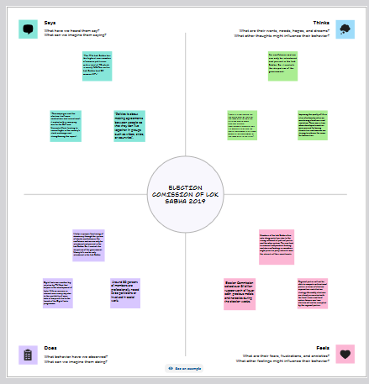:

|  |  |
| --- | --- |
|  |  |
|  |  |
|  |  |
|  |  |
|  |  |
|  |  |
|  |
|  |  |
|  |  |

**2.2 Ideation &Brainstorming Map**

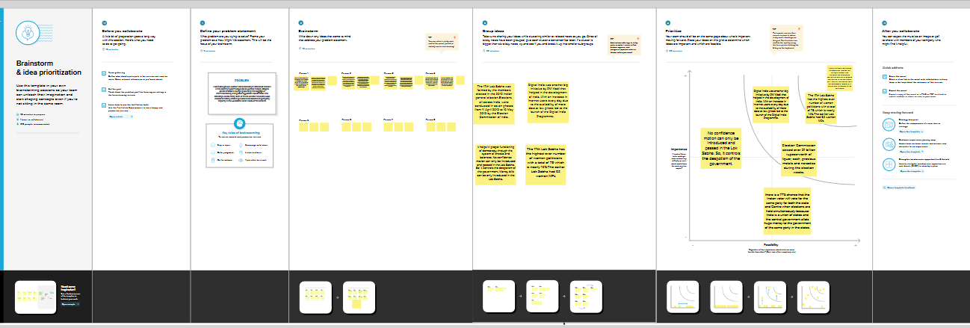

3 RESULT:

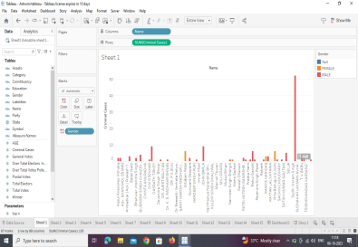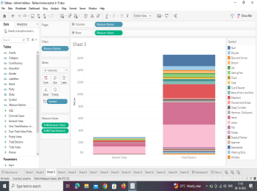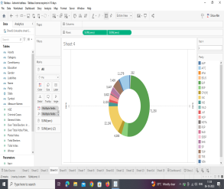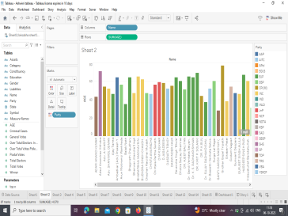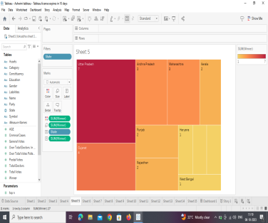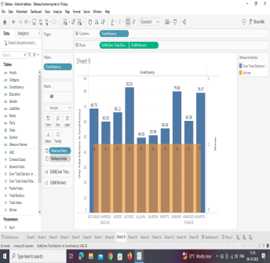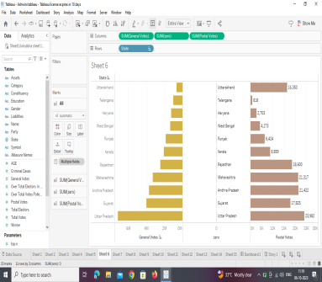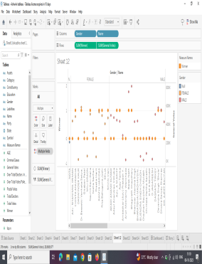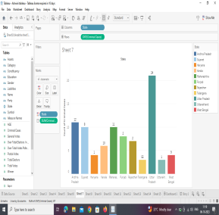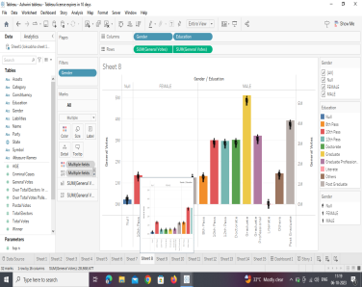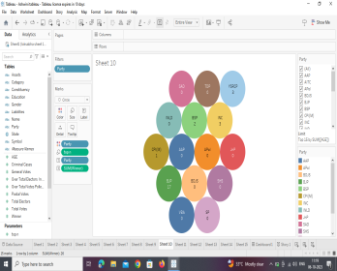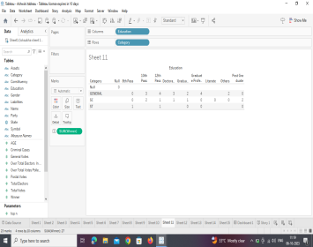

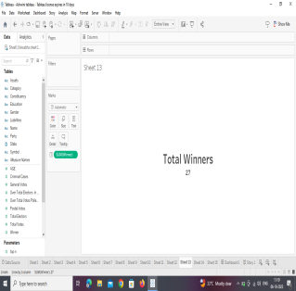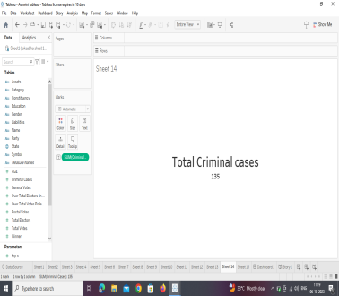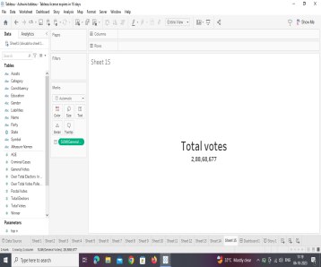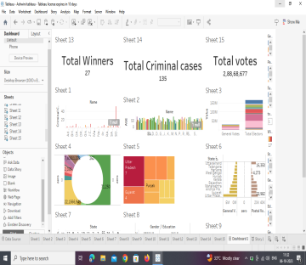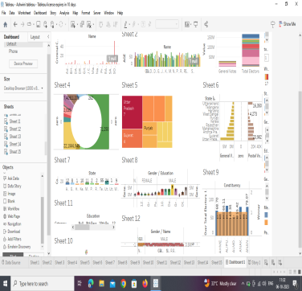

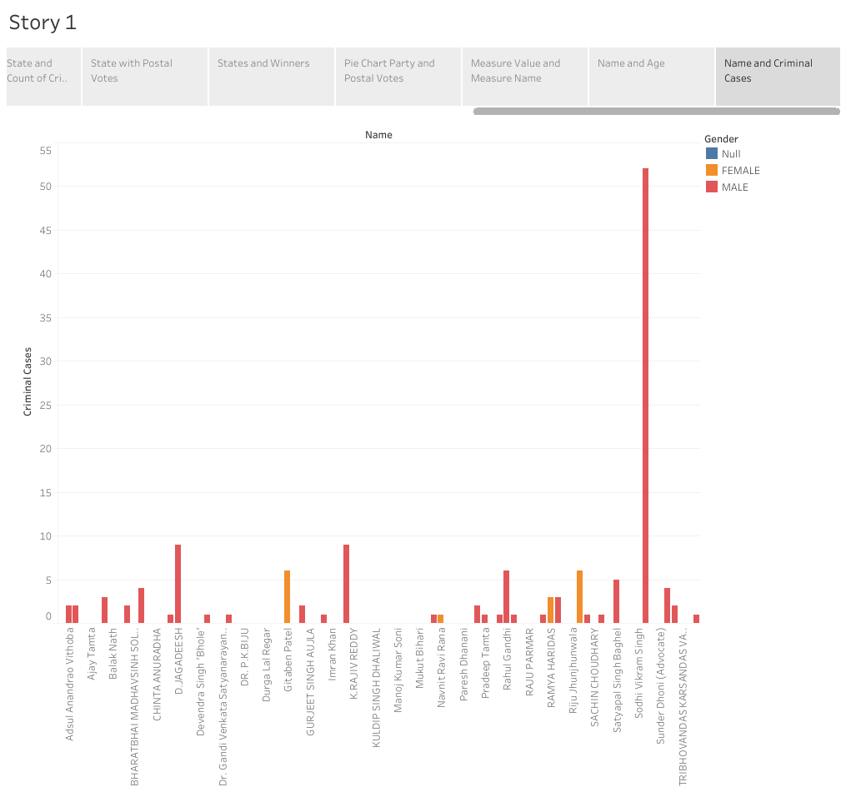

Dashboard:

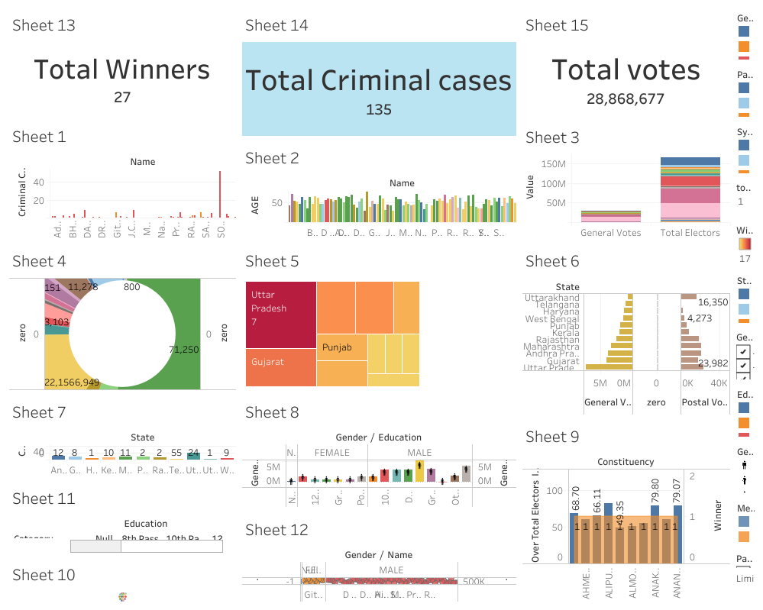

**4. ADVANTAGES & DISADVANTAGES**

**Advantages**:

• It helps in proper functioning of Democracy through the system of

checks and balance. No confidence motion can only be introduced

and passed in the Lok Sabha so it controls the despotism of the

government.

• It composed of representatives of people chosen by direct

election on the basis of Universal Adult Suffrage.

• It is a massive exercise in the system of democratic governance.

The Lok Sabha comprises of a total of 545 seats. Out of these

Election will be conducted by the election commission to fill 543

seats.

**Disadvantages:**

• This can undermine the integrity of the electoral process and

erode public trust democracy.

• The 2019 Lok Sabha election in India is historic not just for its

sheer size but it is historic also for the worth and quantity of

case, drugs, liquor and freebies seized by Vigilance Authorities

during these elections.

• Agrarian and rural distress: The Congress party campaign

highlighted “agrarian distress” as an election issues. The BJP

campaign highlighted that the congress party has been in power

for five generation of Nehru dynasty and its past promises and

campaign issues have been empty.

APPLICATION:

The Election Commission of India has designed is house software for

complete candidate and election management through a software called ENCORE

which stands for Enabling Communications on Real time Environment.

The Election Commission of India has accomplished the constitutional

task of deepening electoral democracy through institution building, transparency

and accessibility, adopting the inclusive approach and strengthening it through

process simplification and proactive inventions. Especially, the various

technological tools have enabled the commission to bring in more efficiency

widespread reach and the accountability in conduct of free and fair election in

recent times.

**FUTURE SCOPE**:

The 2019 Lok Sabha election will tell us whether the combination of

Capitalism Hindutva can be successfully sold to the masses. As for the liberals

both in India and USA they should reflect that it is their policies that paired the

way for both Modi and Trump.

Digital India was another big initiative by PM Modi that helped in the

development of India with an increase in internet users every day led to the

launch of the Digital Programme.

**CONCULSION:**

The Election resulted in a landslide victory for the BJP which won 303

seats and formed the government which the result was declared on 23 May and

Election Observation is a valuable tool for improving the quality of election

observers helps build public confidence in the honesty of electoral processes.

The Solution for the problem of elections, we defined them by creating

KPI’s interactive Visualization and Dashboard and Story board .